Dev Team: Brent, J.P, Ryan

Brite-ball Android Development, triOs College 2018

**horizontal line**

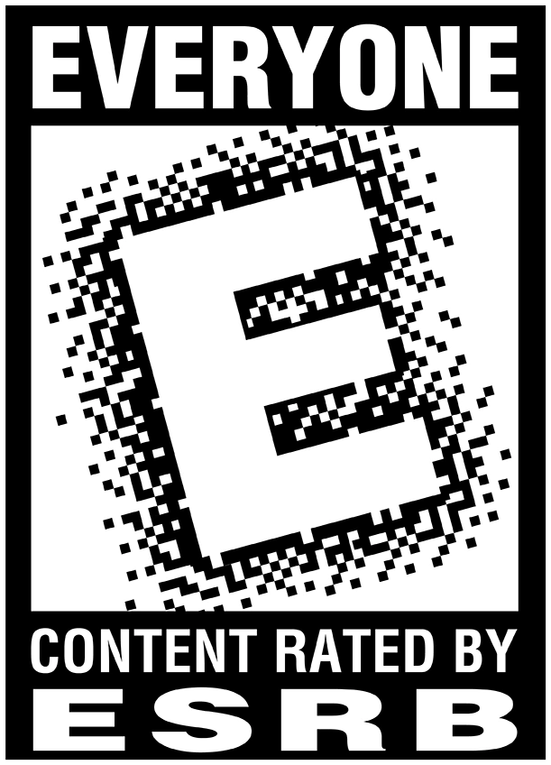

Brite-ball is a simple yet addicting 2d action game for the android platform that will enthrall the player with endless entertainment. This pick-up-and-play styled game will utilize the swipe features of android smartphones to create lines for a basketball to be led into the hoops. This game is geared toward the “everyone” demographic.

**Gameplay Modes -** To begin, there will only be one game mode, which is an endless, high-score based line-drawing mode. The player will have 3 lines (“ink cartridges”) to start with. Each line created by swiping the screen will consume one “ink cartridge”. For each basketball that has successfully gone through the hoop, the player will get an additional “ink cartridge”. The game will be over once the player has run out “ink cartridges”, and must start over from level 1.

**Unique Selling Points -** This game takes advantage of the easy-to-pick-up classification of gaming to create a truly addicting experience. In addition to its fast-paced gameplay, it also cleverly implements the swipe controls to “draw” a line in-game as to contribute to true player integration.

**Competition** - There are many other swipe control games similar to this one, however the simplicity of this game coupled with the excellent art style and music will give

ball the definitive swipe basketball game.